Python Programming Assignment

# Coding Exercises

# Exercise 1: Prime Numbers

Write a Python program that checks whether a given number is prime or not. A prime number is a natural number greater than 1 that has no positive divisors other than 1 and itself.  
  
ANS,

### Using define function first check number is prime number, prime number is greater then 1, if number is 1 or smaller then 1 its not a prime number.

### Using loop to check factors for divisibility 1 and number is self.

### Using user input and output function and calling define function to print result.

### Exercise 2: Product of Random Numbers

Develop a Python program that generates two random numbers and asks the user to enter the product of these numbers. The program should then check if the user's answer is correct and display an appropriate message.

ANS.

1. Importing random function
2. Creating variable for number and using randint for random number in range 1,10.
3. Taking user input for product of random number
4. Creating if statement for user_input to return correct or incorrect value.

### Exercise 3: Squares of Even/Odd Numbers

Create a Python script that prints the squares of all even or odd numbers within the range of 100 to 200. Choose either even or odd numbers and document your choice in the code.  
ANS,  
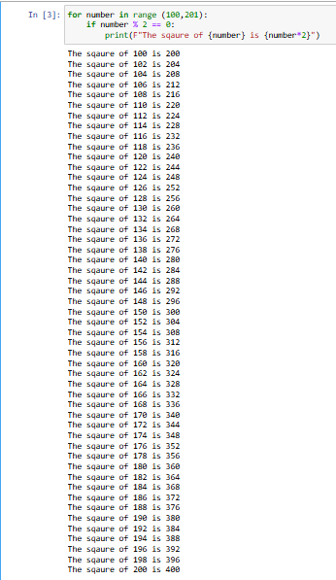

Creating a for loop which directly iterates over the number from 100 to 200 in range (100,201)  
Using If statement to check the current number is % by 0.  
Printing the square if the number is even.

**Exercise 4: Word counter**

write a program to count the number of words in a given text.

example:

input_text = "This is a sample text. This text will be used to demonstrate the word counter."

Expected output:

'This': 2

'is': 1

'a': 1

'sample': 1

'text.': 1

Ans,

From Collections library importing counter function to count occurrence of each word.  
Splitting the text in the list of words based on white spaces.  
Counter function is used to calculate each word in the **TEXT** string.  
Printing iteration over the item word_count with words and its count.

**Exercise 5: Check for Palindrome**

Write a Python function called is_palindrome that takes a string as input and returns True if the string is a palindrome, and False otherwise. A palindrome is a word, phrase, number, or other sequence of characters that reads the same forward and backward, ignoring spaces, punctuation, and capitalization**.**

**Example:**

**Input: "racecar"**

**Expected Output: True**

Ans,

Using define function is_palindrome for String s   
Cleaning and normalizing the string by using the generator expression which coverts the sting to lower case, removed alphanumerical values and joins the remaining string into cleaned string,   
Checking the palindrome using cleaned_string variable is equal to its reverse.  
Using user input for sentences/words.

Please complete the coding exercises and answer the theoretical questions. Submit your work in a single Python (.ipynb) file for the coding exercises.Ensure your code is well-commented to explain your logic and approach. Good luck!